Part 3 a)

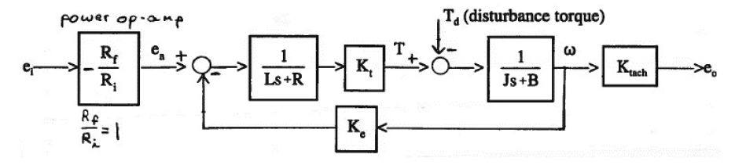The MUT in the open-loop set-up is still connected to the back-drive motor, therefore it would experience both motor’s moment of inertia as well as damping conditions. Assuming both motors are the same, the system equation of the MUT relating the output angular velocity to the input voltage is:

$$\left(E_{a}-K_{e}ω\right)\left(\frac{1}{Ls+R}\right)K_{t}\left(\frac{1}{2Js+2B}\right)=ω$$

$$E_{a}=ω\left(Ls+R\right)\left(2Js+2B\right)K_{t}+K_{e}ω$$

$$E_{a}=ω(\left(Ls+R\right)\left(2Js+2B\right)K_{t}+K_{e})$$

$$E_{a}=ω\left(\left(2JLs^{2}+2BLs+2JRs+2RB\right)K_{t}+K_{e}\right)$$

$$E_{a}=ω[2JLK_{t}s^{2}+2K_{t}\left(BL+JR\right)s+2RBK_{t}+K_{e}]$$

$$e_{a}=2JLK_{t}\ddot{ω}+2K_{t}\left(BL+JR\right)\dot{ω}+(2RBK_{t}+K_{e})ω$$

The transfer function is then:

$$\frac{ω}{E_{a}}=\frac{1}{2JLK_{t}s^{2}+2K_{t}\left(BL+JR\right)s+2RBK_{t}+K_{e}}$$

b) From the block diagram, when the disturbance torque $T_{d}$ is equal to the motor torque $T$, the output velocity would be zero, and $T_{d}$ would equal to the stall torque of the motor at the input voltage.

For $E_{i}=6 V$ input voltage, $E_{a}=-6 V$, at stall torque:

$$\left(E_{a}-K_{e}ω\right)\left(\frac{1}{Ls+R}\right)\left(K_{t}\right)=T$$

Where $K_{e}=4.9817 V/kRPM$ from experimental data, $L=1.3 mH$ from spec sheet, $R=4.2 Ω$ from information given, $s=0$ for step input, and $K_{t}=6.7273 Oz-in/A$ assuming $K_{e}=K_{t}$ and converted to the right units. Since $ω=0$:

$$T=\frac{(-6 V)(6.7273 \frac{Oz∙in}{A})}{1.3 mH (0)+4.2 Ω}=\frac{-40.3638 Oz∙in∙Ω}{4.2 Ω}=-9.6104 Oz∙in$$

The negative sign indicates an arbitrary direction.